Why Do Patients Prefer AI3
Advanced Imaging and Interventional Institute is the Tampa Bay Area’s first and most advanced OUTPATIENT center for Interventional Radiology and Vascular Specialties
- No Over Night Hospital Stays – Patients will return to the comfort of their own homes the same day of procedures
- Less Costly - The services that AI3 provides are much less expensive than the same procedures done in a hospital setting and provide a real financial savings. This could make a difference in hundreds of dollars for personal medical expenses from co-pays and deductibles
- State-Of-The-Art Equipment - The interventional suite at AI3 has equipment which is more advanced than most hospitals in the Tampa area and is a national show site for General Electric Corporation
- Special Care and Patient Education - Patients receive extensive education from the medical staff to learn more about themselves and medical conditions
- Highly Qualified Physicians – All of our doctors are board certified Vascular Interventional Radiologists. Dr. Jerry is the present Chairman of the Economics Committee SIR and has been providing a major role in training standards for physicians performing Interventional Radiology
- Less likely to become ill from infectious disease – 5% of all hospital inpatients acquire an infection of some kind during their stay, according to the US Department of Health and Human Services.
Minimally Invasive Treatment for Uterine Fibroids
Gerald A. Niedzwiecki M.D.
Joseph A. Couvillon M.D.

Advanced Imaging and Interventional Institute
2730 N McMullen Booth Rd Ste 100
Phone: 727-791-7300
Fax: 727-723-9010
www.ai3web.com
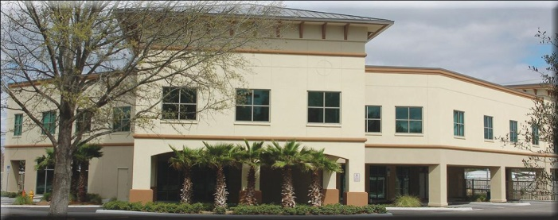
Uterine Fibroid Embolization
Advanced Imaging and Interventional Institute (AI3) is the first and most advanced Interventional Radiologist and Vascular Specialist outpatient center in the Tampa Bay area. AI3 offers a full range of diagnostic imaging and minimally invasive outpatient procedures and is wholly owned and staffed by Board certified and fellowship trained radiologist,
Dr. Gerald Niedzwiecki M.D.

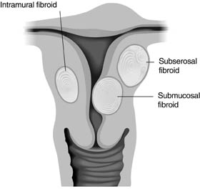
What are Uterine Fibroids?
Uterine fibroids are very common non-cancerous (benign) growths that develop in the muscular wall of the uterus. They can range in size from very tiny (a quarter of an inch) to larger than a cantaloupe. Occasionally, they can cause the uterus to grow to the size of a five-month pregnancy. In most cases, there is more than one fibroid in the uterus. While uterine fibroids do not always cause symptoms, their size and location can lead to problems for some women, including pain and heavy bleeding.
Uterine Fibroids can dramatically increase in size during pregnancy. This is thought to occur because of the increase in estrogen levels during pregnancy. After pregnancy, the fibroids usually shrink back to their pre-pregnancy size. They typically improve after menopause when the level of estrogen, the female hormone that circulates in the blood, decreases dramatically. However, menopausal women who are taking supplemental estrogen (hormone replacement therapy) may not experience relief of symptoms.
Uterine fibroids are the most common tumors of the female genital tract. You might hear them referred to as “fibroids” or by several other names, including leiomyoma, leiomyomata, myoma and fibromyoma. Fibroid tumors of the uterus are very common, but for most women, they either do not cause symptoms or cause only minor symptoms.
Uterine Fibroid Embolization
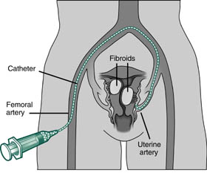
Uterine fibroid embolization (UFE), also known as uterine artery embolization, is a myomectomy and hysterectomy alternative. UFE’s are performed by an interventional radiologist, a physician who is trained to perform this and other types of embolization and minimally invasive procedures. It is performed while the patient is conscious, but sedated and feeling no pain. It does not require general anesthesia, but some patients choose to have it.
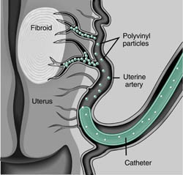
The interventional radiologist makes a tiny nick in the skin in the groin and inserts a catheter into the femoral artery. Using real-time imaging, the physician guides the catheter through the artery and then releases tiny particles, the size of grains of sand, into the uterine arteries that supply blood to the fibroid tumor. This blocks the blood flow to the fibroid tumor and causes it to shrink and die.
How long until I can return to work after UFE?
The average recovery time before patients return to work or their normal daily activities is approximately one week.
How long will it take for my symptoms to resolve following UFE?
Most patients notice a difference in heavy menstrual bleeding (menorrhagia) by their next cycle. Bulk related symptoms including pelvic pain, pressure, frequent urination and constipation make take up to three to five months to notice a significant difference.

